Helper Instructions

Thank you for being a helper during this session!

All material is already deployed on the ACCESS Pegasus system. Attendees should log in using their ACCESS credentials:

<https://pegasus.access-ci.org>

In case we experience any network issues, we will have videos of the tutorials. Presenter will show the videos, and these tutorials can be completed later in a self-guided fashion by the attendees.

Attendees should start a notebook with lifetime of 2 hours:

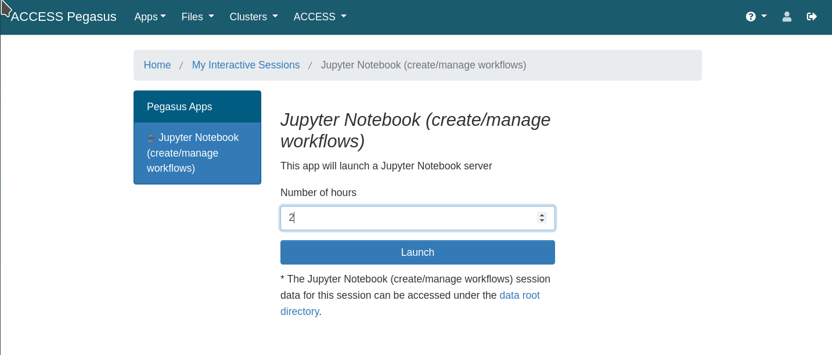

Material will can be found in the Jupyter file browser, under **ACCESS-Pegasus-Examples** - all users should already have this directory in their $HOME.

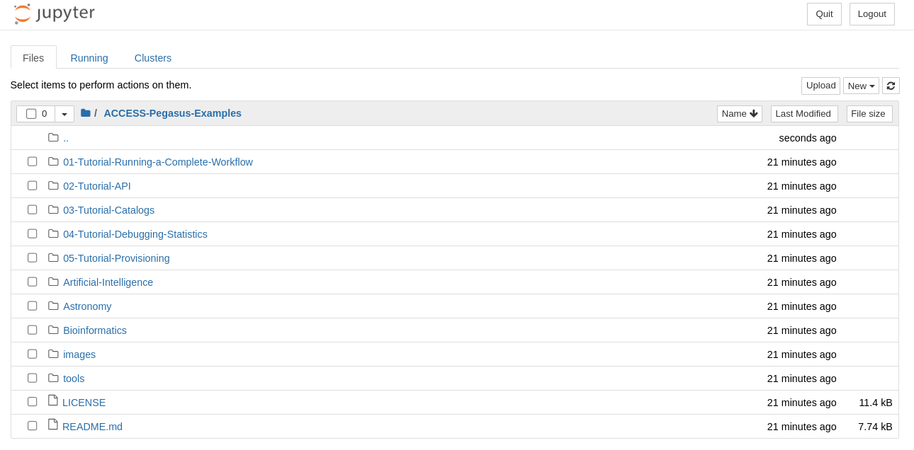

Time permitting, we will run 01, 03, and 04 tutorials. Note that we are skipping 02 and 05.

* 01-Tutorial-Running-a-Complete-Workflow
* 03-Tutorial-Catalogs
* 04-Tutorial-Debugging-Statistics

The presenter will have slides in between each one. There is a chance that attendees will not have time to finish each one during the allotted time - this is not an issue. Attendees can leave the notebooks running during the next round of slides, and/or come back later and finish the tutorial.

The tutorials are mostly self-guided. Attendees should just have to step through the cells one by one (using the button)

## 01-Tutorial-Running-a-Complete-Workflow

The objective of this tutorial is to run a simple workflow, but not worry too much about all the details.

## 03-Tutorial-Catalogs

The objective of this tutorial is to better understand catalogs.

## 04-Tutorial-Debugging-Statistics

The objective of this tutorial is to learn about Pegasus’ tools for debugging failed workflows, and pull out information from the provenance database.